# 

Home Hadoop Cluster

Linux and Cloudera Install

Brian Baillod

# Introduction

I wanted to set up a home Hadoop cluster for educational and demonstration purposes. Alex Breshears and Matt Harris provided some excellent guidance as they had already done this. I took the time to document this as I occasionally get requests from people who want to do this themselves.

I’m assuming that you have procured four or more bare metal servers and that you want to first install Linux and second install Cloudera. I have created a companion document which discusses server selection.

I’m also assuming that you have a working knowledge of Linux such that extra guidance with the install and configuration are helpful to you.

# Installing Linux

## Install Centos 6.5

It is likely that you will need to do a bare metal install where you need to set the BIOS on the servers to boot from either a USB or from a DVD drive.

**How to make a bootable Centos 6.5 USB drive using a Mac**

1. Download the minimal Centos 6.5 ISO or use wget curl

2.  Format 8GB or larger USB as exFAT using Mac Disk Utility Erase tab.  Disk needs to be empty.

3.  In the MAC terminal window with the USB drive inserted:

Unmount the Disk, otherwise it is busy

*sudo diskutil unmountDisk /dev/disk2*

mount command will tell you the /dev information for the USB

Mine was /dev/disk2s1 - leave off the s1

4. use the DD command to do a raw write of the ISO image to the USB

*sudo dd if=/Users/bbaillod/Desktop/CentOS-6.5-x86\_64-bin-DVD1.isoof=/dev/disk2 bs=1m*

I used the Full Centos image which gives you the choice of all the minimal versions to install as well as full desktop.  Was 4.7GB, took 80 minutes to write to the USB.

It would have been faster to use the Minimal install.

## CENTOS Install Screenshots

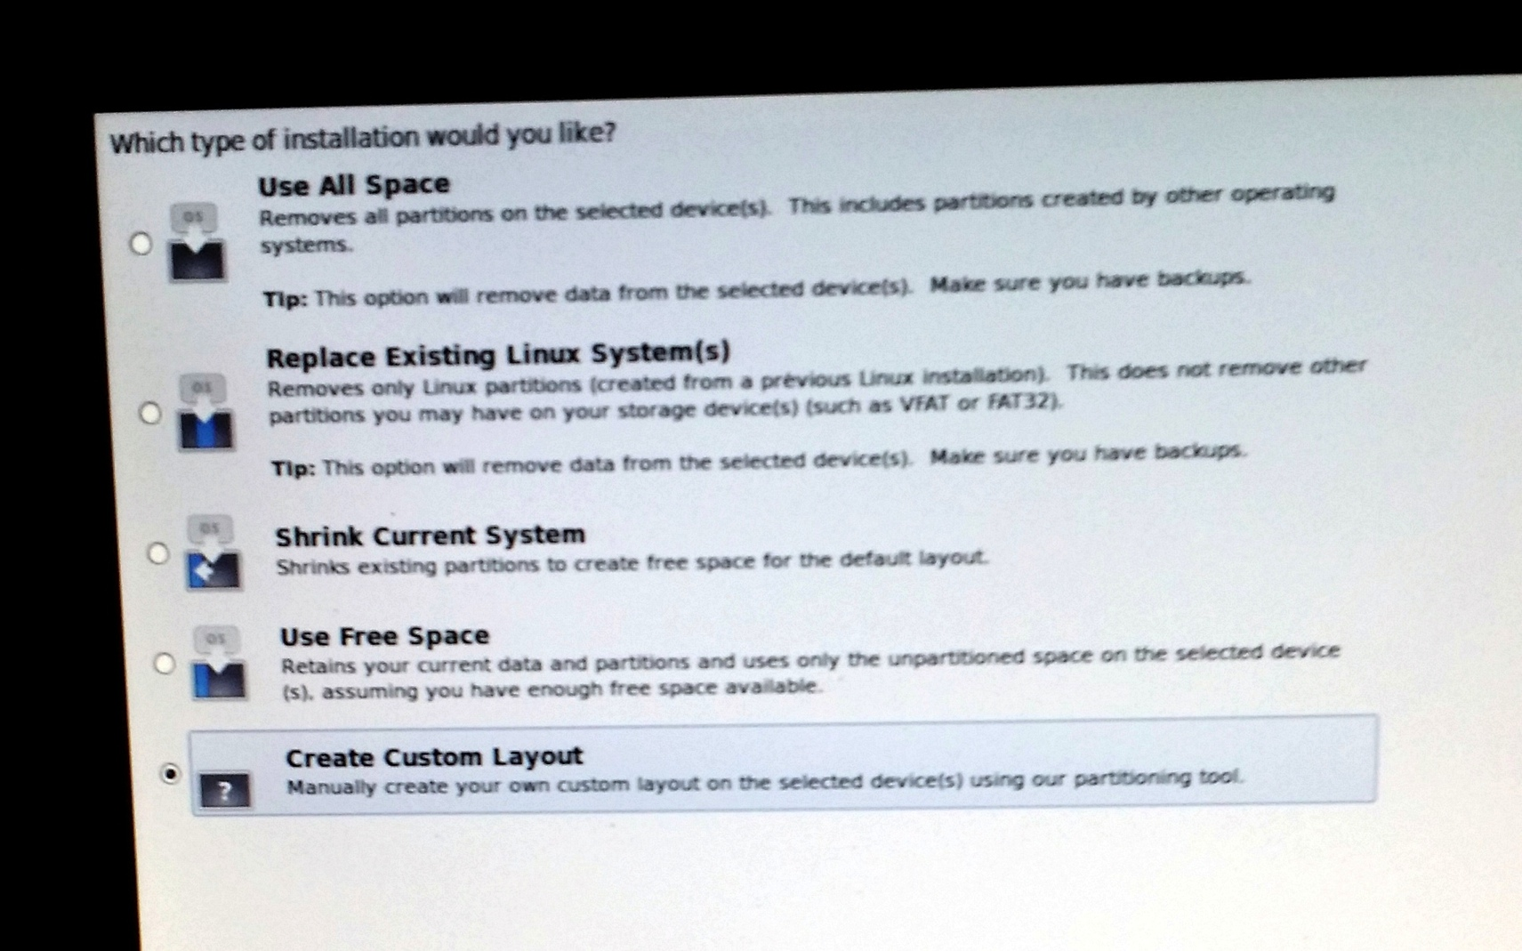

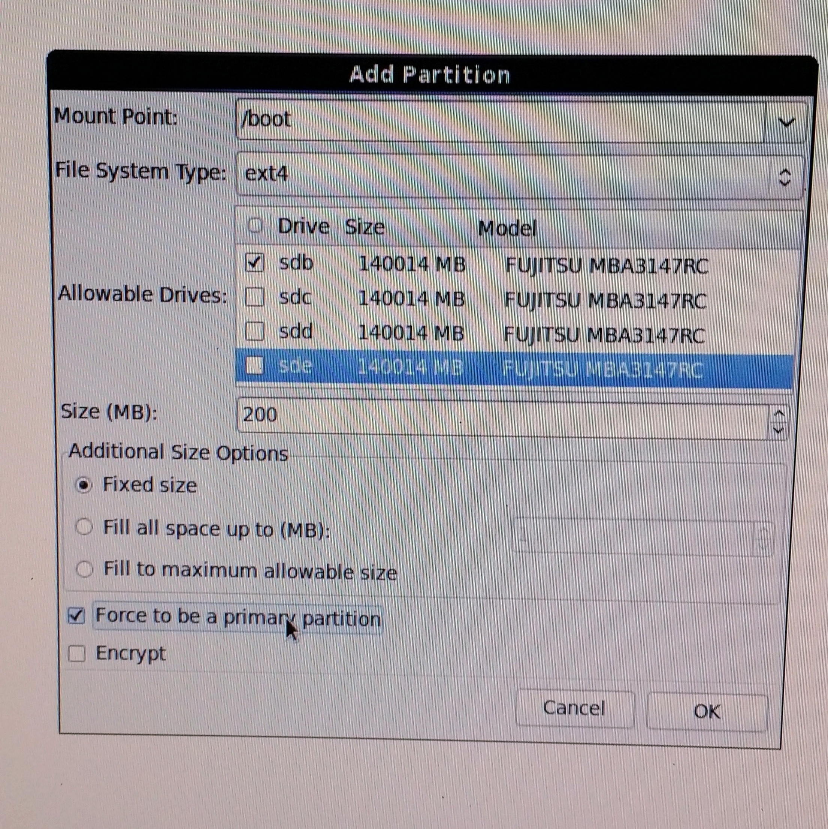

Mount data disks as JBODs.  no striping, LVM, or RAID necessary with HDFS.  In fact, this slows down HDFS workloads. Use the EXT4 filesystem.

You need a “noatime” parameter on your data partitions in /etc/fstab

* Make sure the mounts you’re using for DFS and MapReduce storage have been mounted with the noatime option. This disables access time tracking and can improve IO performance.

**Partition Size overview**

Root needs 70GB if VAR is a part of it

VAR needs 30GB (20GB shown in screenshot was too small) – can be under root or separate

Swap needs 2 to 12GB

Rest goes to data. Create a data partition on each physical disk.

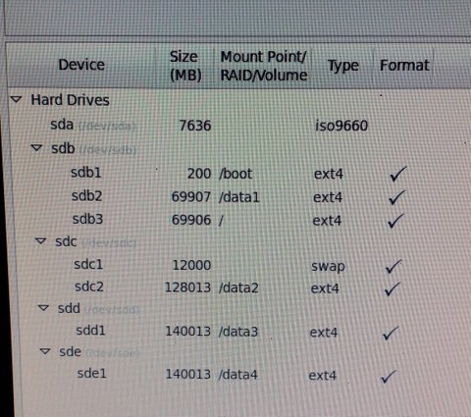

**/etc/fstab example** (Edit file and add noatime parameter as shown on HDFS data mounts. /data1, /data2, etc.)

UUID=9368806b-2eb9-413a-a375-0d1d58af4c08 / ext4 defaults 1 1

UUID=9c759cbc-aaf4-400a-943e-17a5ec738310 /boot ext4 defaults 1 2

UUID=4bccb632-c757-44c1-8866-a06d3114291f /data1 ext4 defaults,**noatime**  1 2

UUID=4bccb632-c757-44c1-8866-a06d3114291f /data2 ext4 defaults,**noatime**  1 2

UUID=4bccb632-c757-44c1-8866-a06d3114291f /data3 ext4 defaults,**noatime**  1 2

UUID=3df86535-93be-401c-9829-23b9e698416b swap swap defaults, 0 0

1. **Network Configuration**

The four primary network configuration files are as follows:

**/etc/hosts** The main purpose of this file is to resolve hostnames that cannot be resolved any other way. It can also be used to resolve hostnames on small networks with no DNS server.

**/etc/resolv.conf** This file specifies the IP addresses of DNS servers and the search domain

**/etc/sysconfig/network** This file specifies routing and host information for all network interfaces.

**/etc/sysconfig/network-scripts/ifcfg-*<interface-name>*** For each network interface, there is a corresponding interface configuration script. Each of these files provide information specific to a particular network interface.

1. **Edit /etc/hosts**

Make sure /etc/hosts does NOT have a hostname tied to the localhosts line.  Some versions of Linux will do this incorrectly and this will create issue for Java applications.

For example, there should not be a line:

127.0.0.1 localhost localhost.localdomain myHostName

Instead it should be like this: 10.0.0.1 [myhost.domainname.com](http://myhost.domainname.com/) myhost

**Example /etc/hosts**

127.0.0.1 localhost

10.0.1.100 musky.datalake.net musky

10.0.1.101 pike.datalake.net pike

10.0.1.102 bass.datalake.net bass

10.0.1.103 perch.datalake.net perch

**b. Edit /etc/sysconfig/network-scripts/ifcfg-eth0:**

**Example: provide your IP, FQDN, DNS, MAC, NETMASK etc.**

DEVICE="eth0"

HWADDR="00:1C:23:E1:9E:88"

TYPE="Ethernet"

UUID="c6418dc0-bf8d-448b-aa16-c040bb9c5aef"

BOOTPROTO=static

IPV6INIT=yes

MTU=1500

NETMASK=255.255.255.0

NM\_CONTROLLED=yes

ONBOOT="yes"

DNS1=8.8.8.8

GATEWAY=10.0.1.1

IPADDR=10.0.1.100

HOSTNAME=musky.datalake.net

**c. Edit or create /etc/resolv.conf** to assign the DNS nameserver

Example:

# Google DNS

nameserver 8.8.8.8

**d. Edit /etc/sysconfig/network**

Example contents:

NETWORKING=yes

HOSTNAME=walleye.datalake.net

GATEWAY=10.0.1.1

1. **Preinstall Linux settings you can change on all machines in parallel using csshx**

Use the Mac csshX utility on an IP range as shown to open multiple parallel SSH windows

csshx --login root 10.0.1.[100-103]

**a. Add the EPEL RM repository which contains some packages you will need**

curl -O http://mirror.steadfast.net/epel/6/x86\_64/epel-release-6-8.noarch.rpm

rpm -i epel-release-6-8.noarch.rpm

**b. Add some missing packages that the minimal Centos install does not include.**

yum install ntp

yum install bind-utils   # contains dig

yum install openssh-clients #scp and sftp

yum install python

yum install curl

yum install wget

yum install java-devel

yum install git

**c. Turn off swappiness**

echo "vm.swappiness=0" >> /etc/sysctl.conf

**d. Configure NTP**

ntpdate 0.us.pool.ntp.org

chkconfig ntpd on

edit /etc/ntp.conf so NTP survives VM sleeps without freaking out:

add the line "tinker panic 0" at the top

comment out "server 127.127.1.0" and "fudge 127.127.1.0 stratum 10"

service ntpd start

**e. Disable unnecessary IP services**

chkconfig iptables off

chkconfig ip6tables off

**f. Miscellaneous Settings**

If using DNS, make sure forward and reverse resolution are consistent and only return one value each with hostname -f

Transparent hugepage bug workaround:

         sudo echo never> /sys/kernel/mm/redhat\_transparent\_hugepage/defrag

Disable SELinux

edit /etc/sysconfig/selinux and change the SELINUX= line to this: SELINUX=disabled

|  |
| --- |
|  |

1. **Copy Cloudera Manager BIN file to your namenode server**

Download cloudera-manager-installer.bin from [Cloudera Downloads](http://www.cloudera.com/content/support/en/downloads.html" \t "_blank) to the host where you want to install the Cloudera Manager Server. The host must be on your cluster or accessible to your cluster over your network. Install Cloudera Manager on a single host.  
Upload from your computer: $ scp cloudera-manager-installer.bin root@musky:~  
Get directly from the Cloudera Archive: wget http://archive.cloudera.com/cm5/installer/latest/cloudera-manager-installer.bin

Change cloudera-manager-installer.bin to have executable permission.

$ chmod u+x cloudera-manager-installer.bin

Run cloudera-manager-installer.bin. You may need to first reboot the servers to pick up some of the config changes from above such as SELINUX=disabled

$ sudo ./cloudera-manager-installer.bin

Uninstall: Uninstall Cloudera Manager by running: /usr/share/cmf/uninstall-cloudera-manager.sh

1. **Follow Install Path A for CDH5**

<http://www.cloudera.com/content/cloudera-content/cloudera-docs/CM5/latest/Cloudera-Manager-Installation-Guide/cm5ig_install_path_A.html?scroll=cmig_topic_6_5>’

**Sample Cluster Configuration:**

Master Node: Musky: Namenode

Data Node 1: Bass: Secondary Namenode

Data Node 2: Perch:

Data Node 3: Pike:

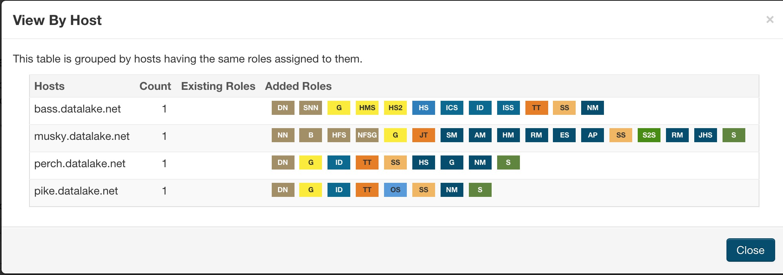

**7. Troubleshooting:**

Look at the last entries in the install log

Cd/var/log/Cloudera/….

If you have Oracle JDK issues

Yum search jdk

Look in /etc/yum/repos.d

Java –version -- shows the java version

Rpm –i jdk -- will reinstall the JDK manually

Pscp will move files to all nodes at once -- parallel scp

Parallel ssh – csshx for max pssh for linux csshx --login root 10.0.1.[100-103]

Yum clean all – resets the yum repository

Failed to receive heartbeat from agent – networking problem most likely.

Note; If upgrading, all namenode metadata directories must be deleted first. /data1/dfs/nn /data2/dfs/nn etc.